|  |
| --- |
| NAME: Ayush Vinod Upadhyay  ROLL NO: I025  SAP ID: 60003220131  BRANCH: Information Technology  BATCH: 1 |

**Aim:** To implement Inheritance

**Problem Statement 1**: WAP to demonstrate the role of Constructors in inheritance in the following class diagram:

|  |  |
| --- | --- |
|  |  |

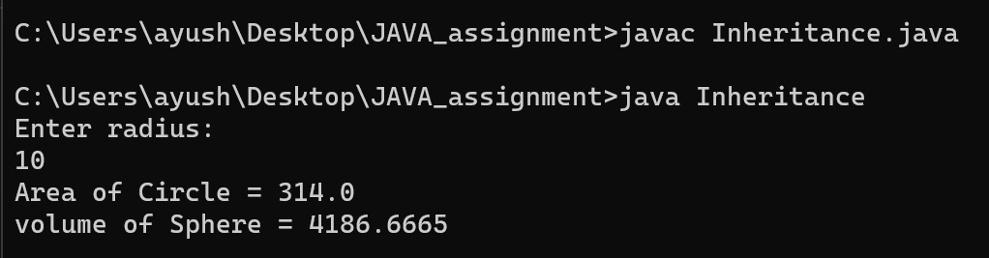

**Problem Statement 2:** Display data of the specialized classes given in the following class diagram.

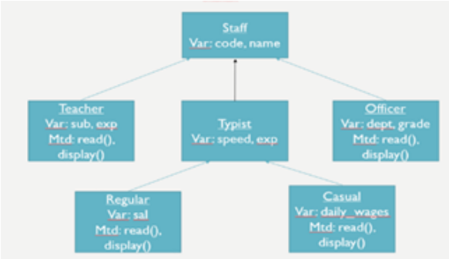

CODE:  
  
import java.util.*;

class Staff

{

int code;

String name;

Scanner sc = new Scanner (System.in);

}

class Teacher extends Staff

{

String subject;

int experience;

public void read()

{

System.out.println("Enter name of the teacher: ");

name=sc.nextLine();

System.out.println("Enter code of the teacher: ");

code=sc.nextInt();

sc.nextLine(); // Consume the newline character

System.out.println("Enter subject of the teacher: ");

subject=sc.nextLine();

System.out.println("Enter years of experience of the teacher: ");

experience=sc.nextInt();

System.out.println("");

}

public void display(){

System.out.println("The name of the teacher is: "+name);

System.out.println("The code of the teacher is: "+code);

System.out.println("The subject of the teacher is: "+subject);

System.out.println("The years of experience of the teacher is: "+experience);

}

}

class Officer extends Staff{

String grade;

String department;

public void read(){

System.out.println("Enter name of the Officer: ");

name=sc.nextLine();

System.out.println("Enter code of the Officer: ");

code=sc.nextInt();

sc.nextLine(); // Consume the newline character

System.out.println("Enter grade of the officer: ");

grade=sc.nextLine();

System.out.println("Enter department of the officer: ");

department=sc.nextLine();

System.out.println("");

}

public void display(){

System.out.println("The name of the Officer is: "+name);

System.out.println("The code of the Officer is: "+code);

System.out.println("The grade of the Officer is: "+grade);

System.out.println("The department of the Officer is: "+department);

}

}

class Typist extends Staff

{

int speed;

int experience;

}

class Regular extends Typist

{

int salary;

public void read()

{

System.out.println("Enter name of the Regular Typist: ");

name=sc.nextLine();

System.out.println("Enter code of the Regular Typist: ");

code=sc.nextInt();

System.out.println("Enter speed of the Regular Typist: ");

speed=sc.nextInt();

System.out.println("Enter years of experience of the Regular Typist: ");

experience=sc.nextInt();

System.out.println("Enter salary of the Regular Typist: ");

salary=sc.nextInt();

System.out.println("");

}

public void display()

{

System.out.println("The name of the Regular Typist is: "+name);

System.out.println("The code of the Regular Typist is: "+code);

System.out.println("The speed of the Regular Typist is: "+speed);

System.out.println("The years of experience of the Regular Typist is: "+experience);

System.out.println("The salary of the Regular Typist is: "+salary);

}

}

class Casual extends Typist

{

int dailywages;

public void read()

{

System.out.println("Enter name of the Casual Typist: ");

name=sc.nextLine();

System.out.println("Enter code of the Casual Typist: ");

code=sc.nextInt();

System.out.println("Enter speed of the Casual Typist: ");

speed=sc.nextInt();

System.out.println("Enter years of experience of the Casual Typist: ");

experience=sc.nextInt();

System.out.println("Enter daily wages of the Casual Typist: ");

dailywages=sc.nextInt();

System.out.println("");

}

public void display()

{

System.out.println("The name of the Casual Typist is: "+name);

System.out.println("The code of the Casual Typist is: "+code);

System.out.println("The speed of the Casual Typist is: "+speed);

System.out.println("The years of experience of the Casual Typist is: "+experience);

System.out.println("The dailt wages of the Casual Typist is: "+dailywages);

}

}

public class Student{

public static void main(String[] args)

{

Teacher t= new Teacher();

Officer o = new Officer();

Regular r = new Regular();

Casual c = new Casual();

t.read();

o.read();

r.read();

c.read();

System.out.println("");

t.display();

System.out.println("");

o.display();

System.out.println("");

r.display();

System.out.println("");

c.display();

}

}

